**MIDDLETON CHENEY FOOTBALL CLUB ANNUAL GENERAL MEETING 1981**

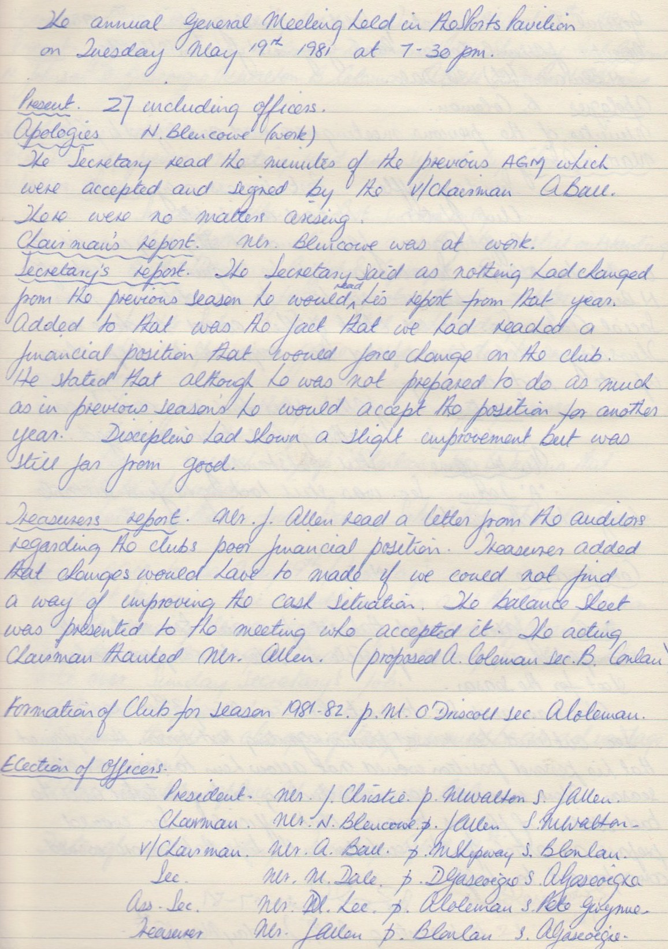

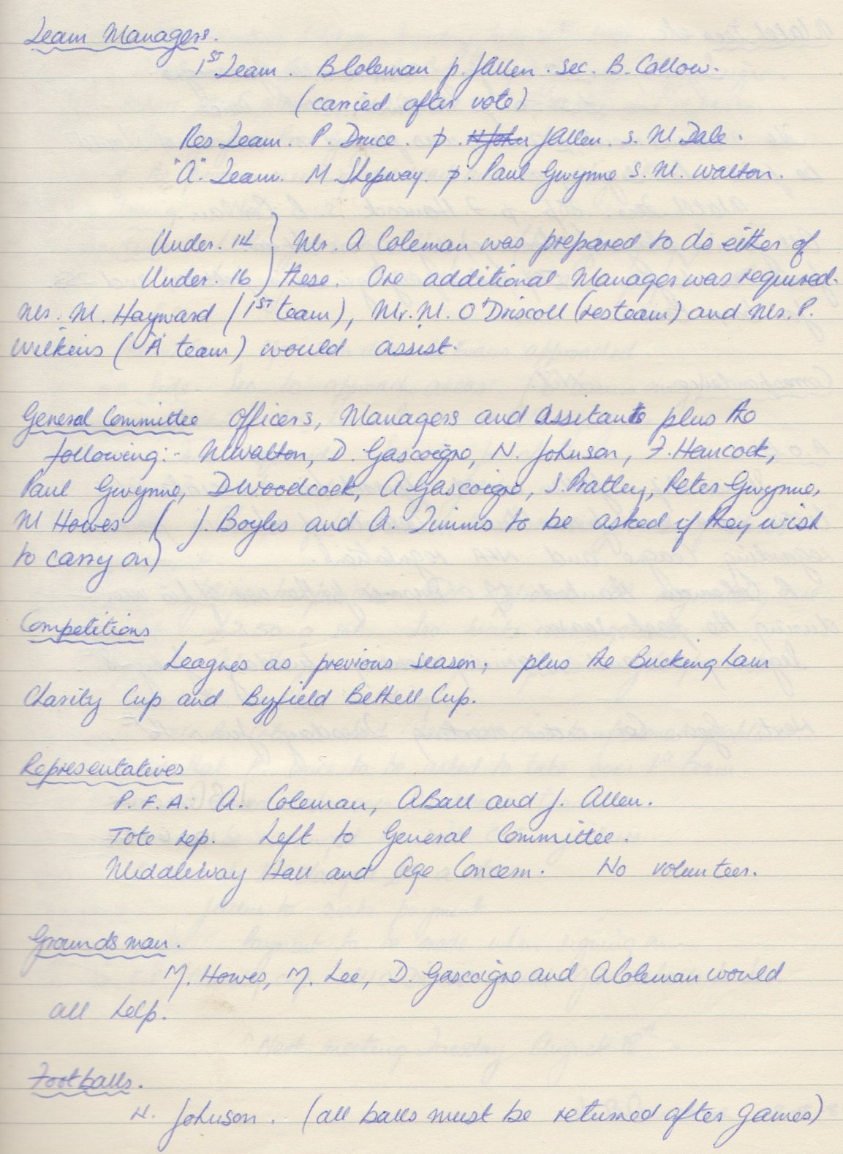

**Continued**

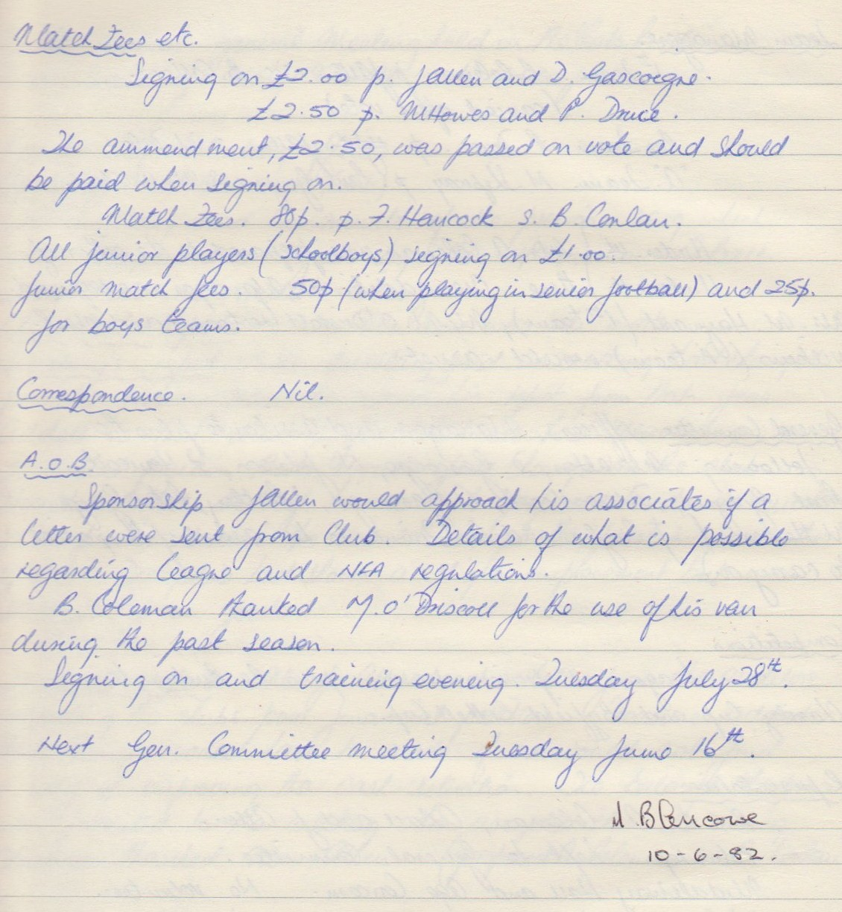

**General Committee Meeting**

**July 21st 1981**

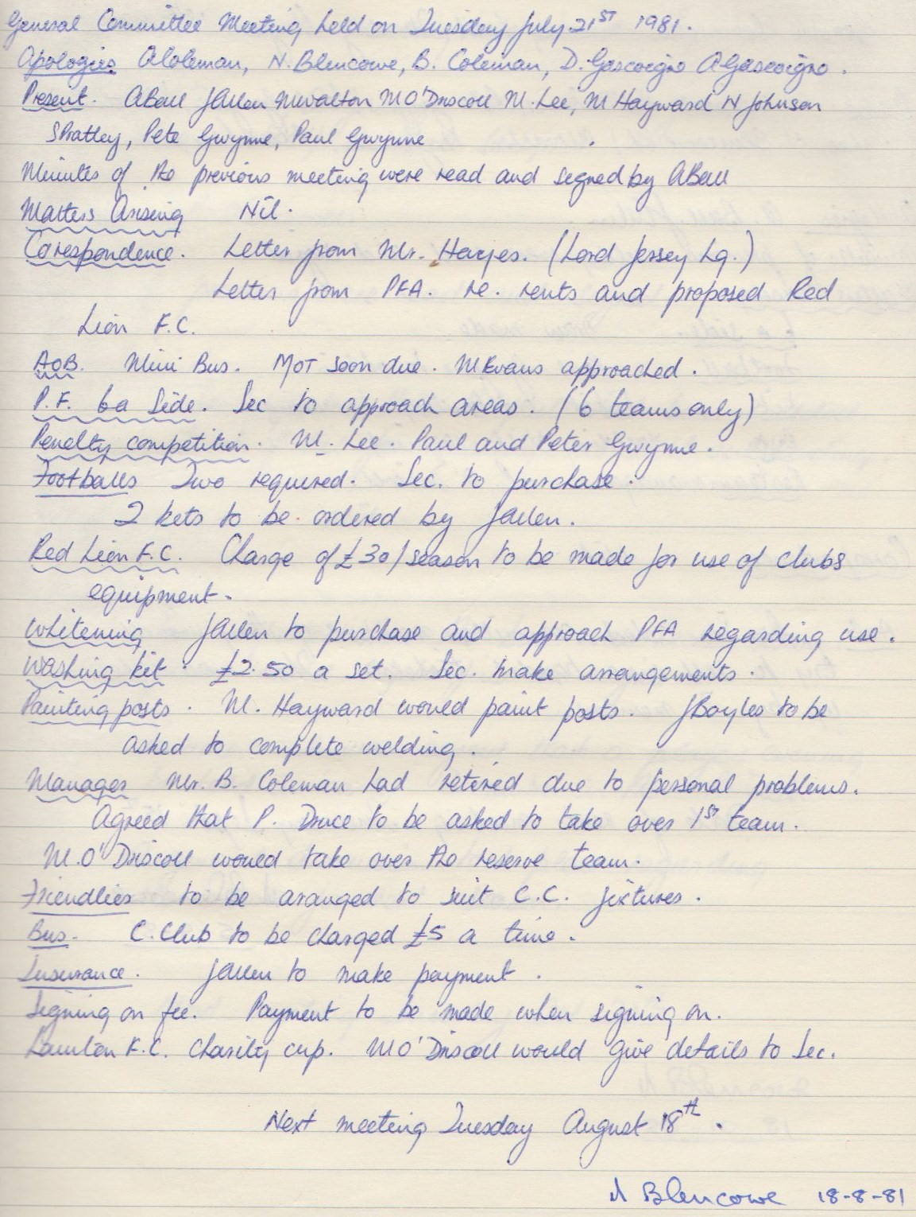

**General Committee Meeting**

**August 18th 1981**

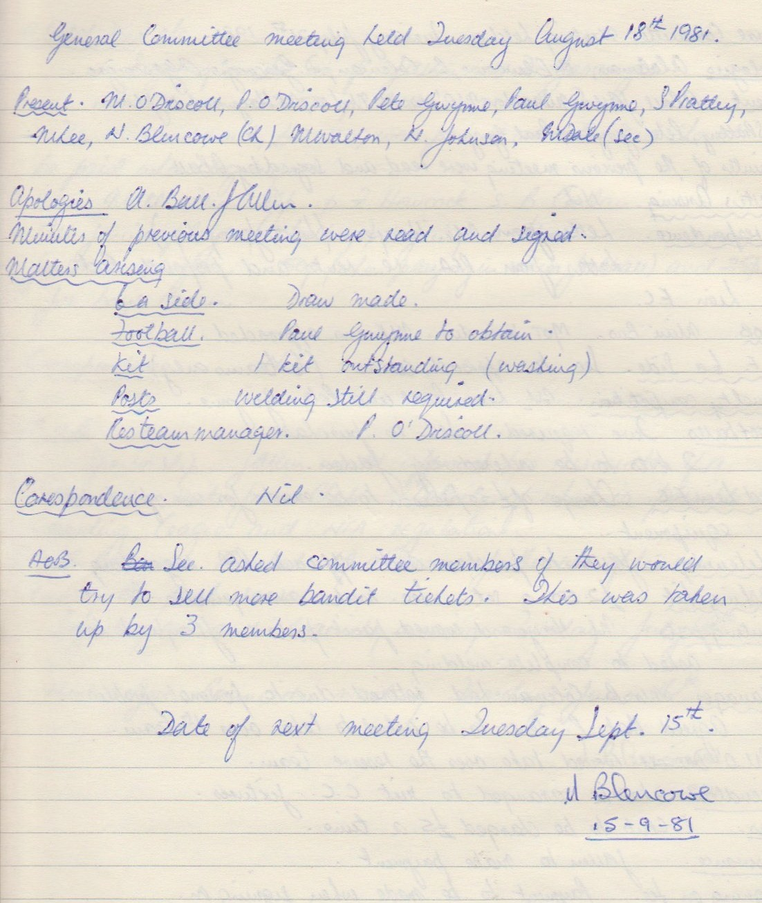

**General Committee Meeting**

**September 15th 1981**

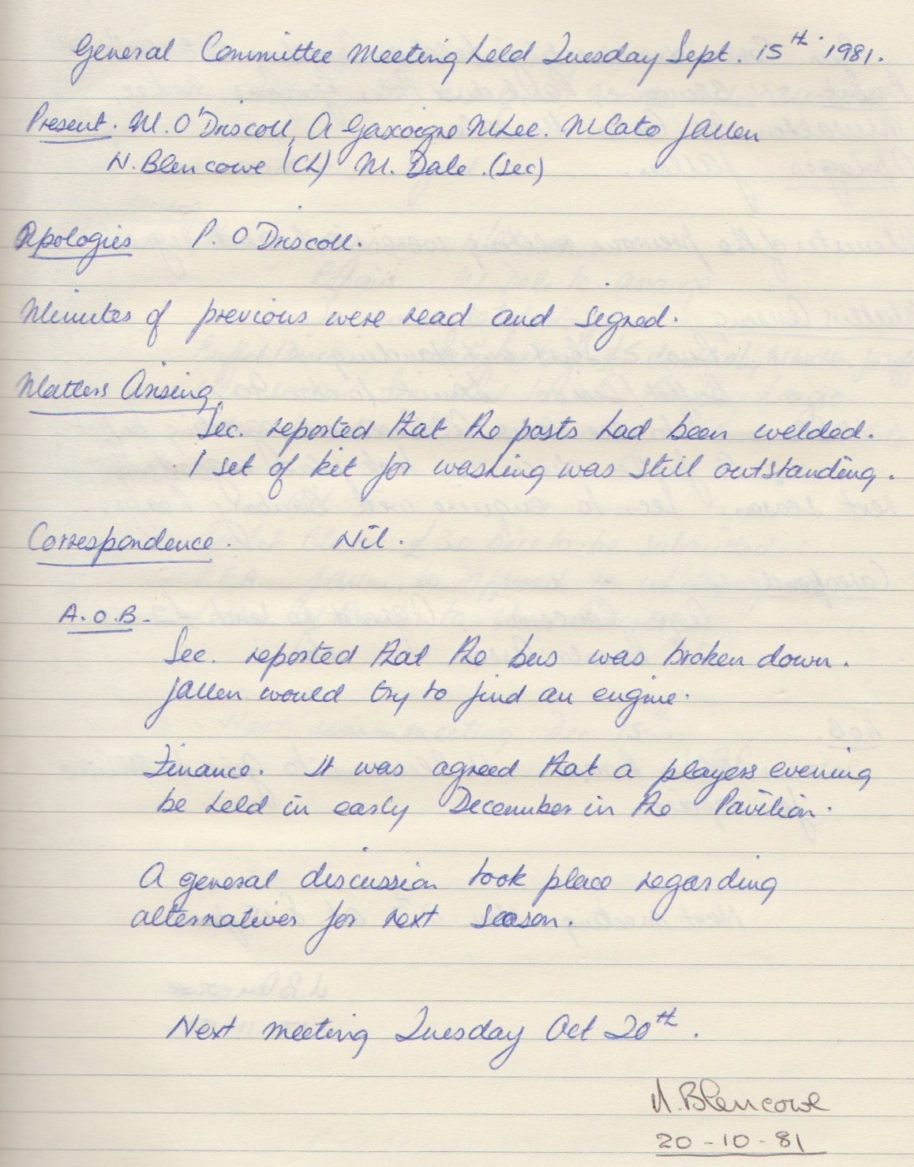

**General Committee Meeting**

**October 20th 1981**

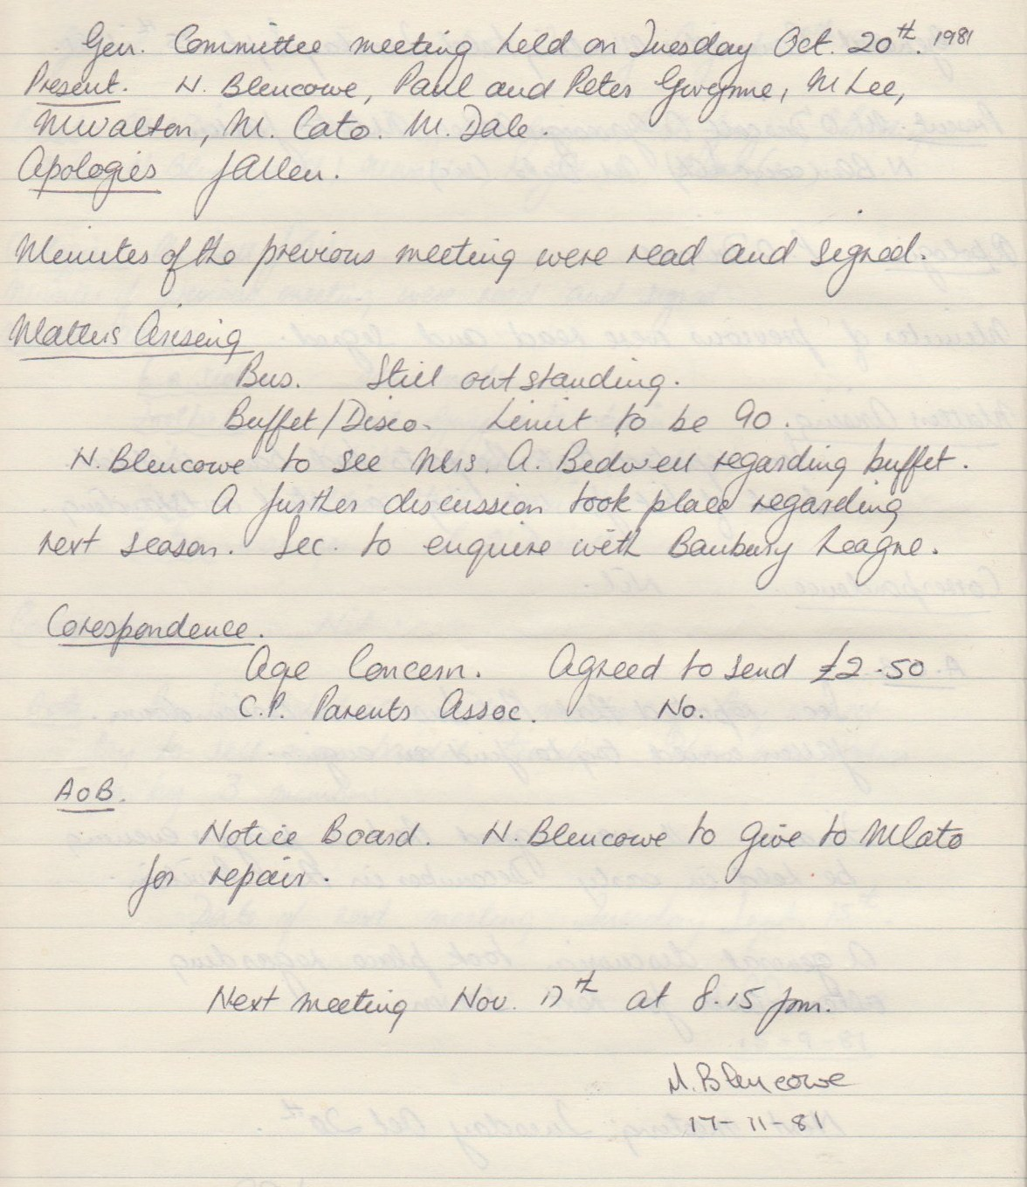

**General Committee Meeting**

**November 17th 1981**

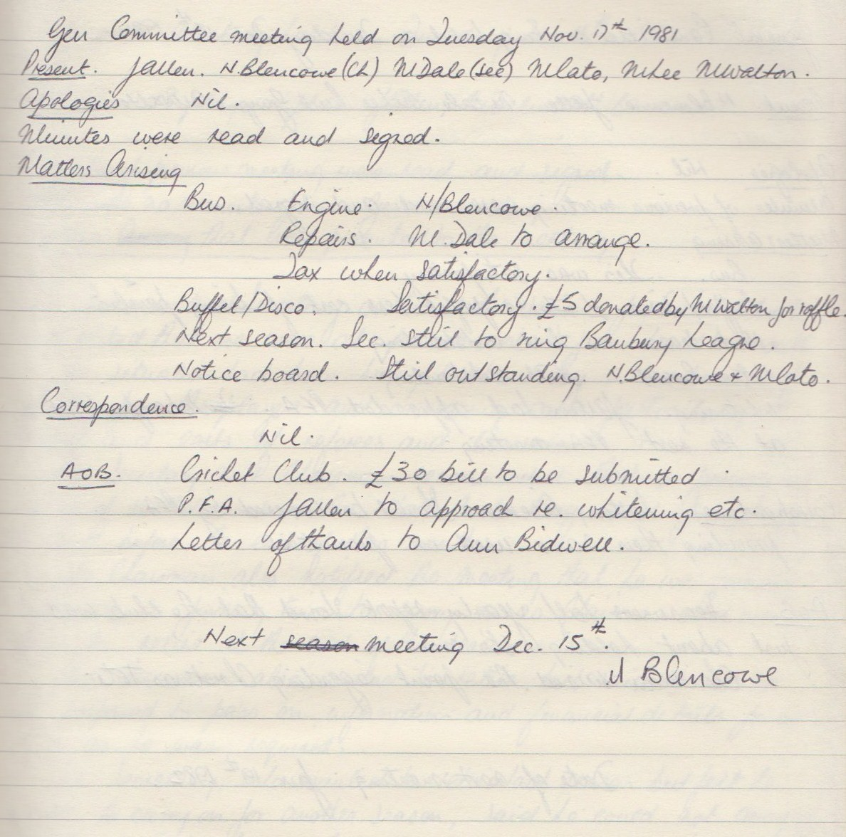

**General Committee Meeting**

**December 15th 1981**

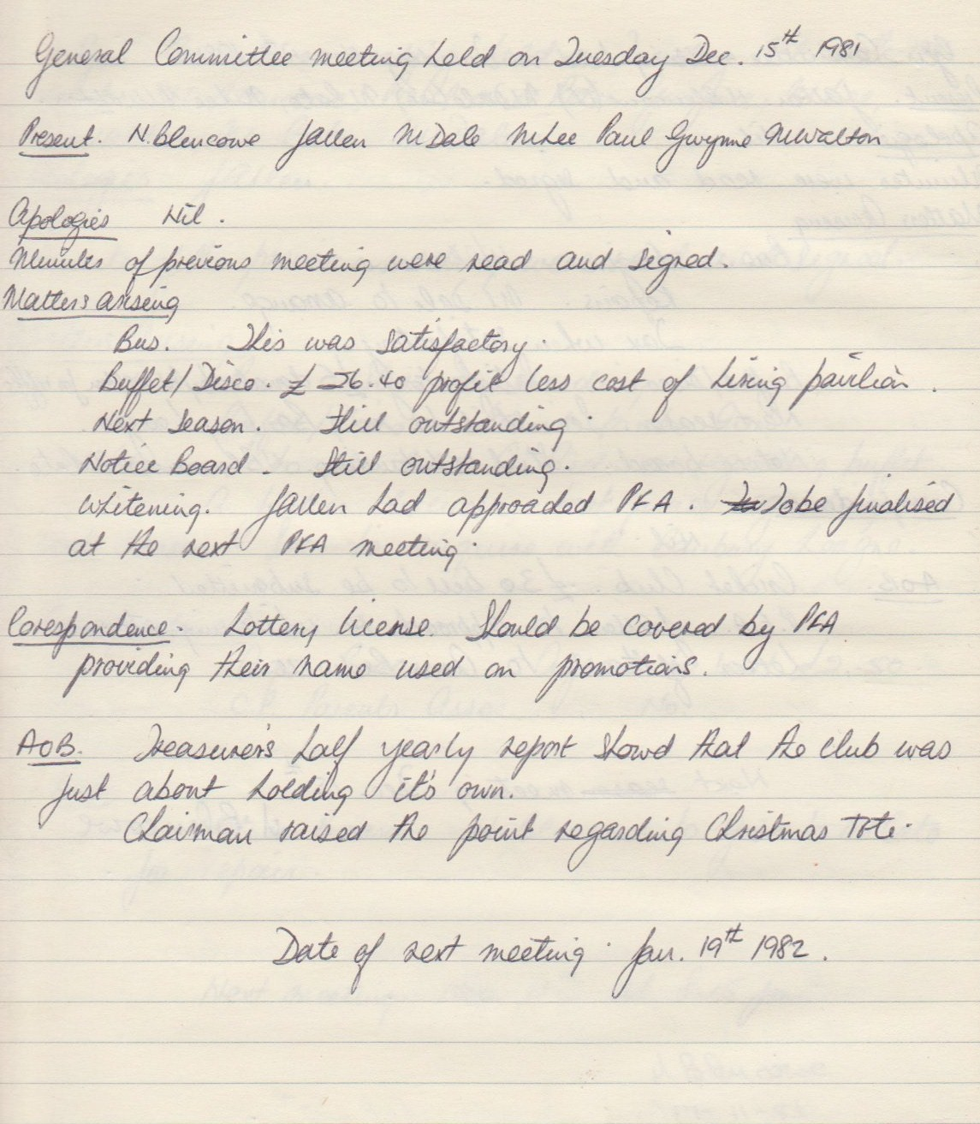

**General Committee Meeting**

**February 16th 1982**

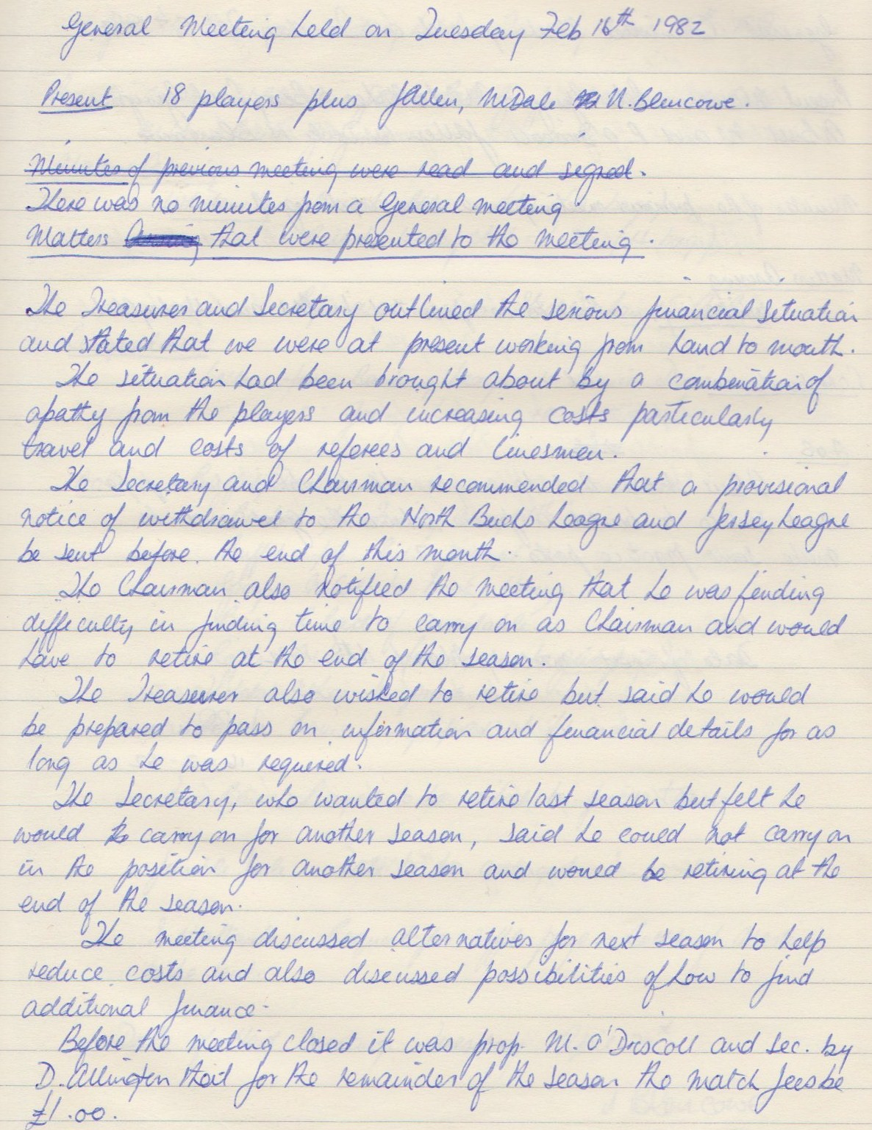

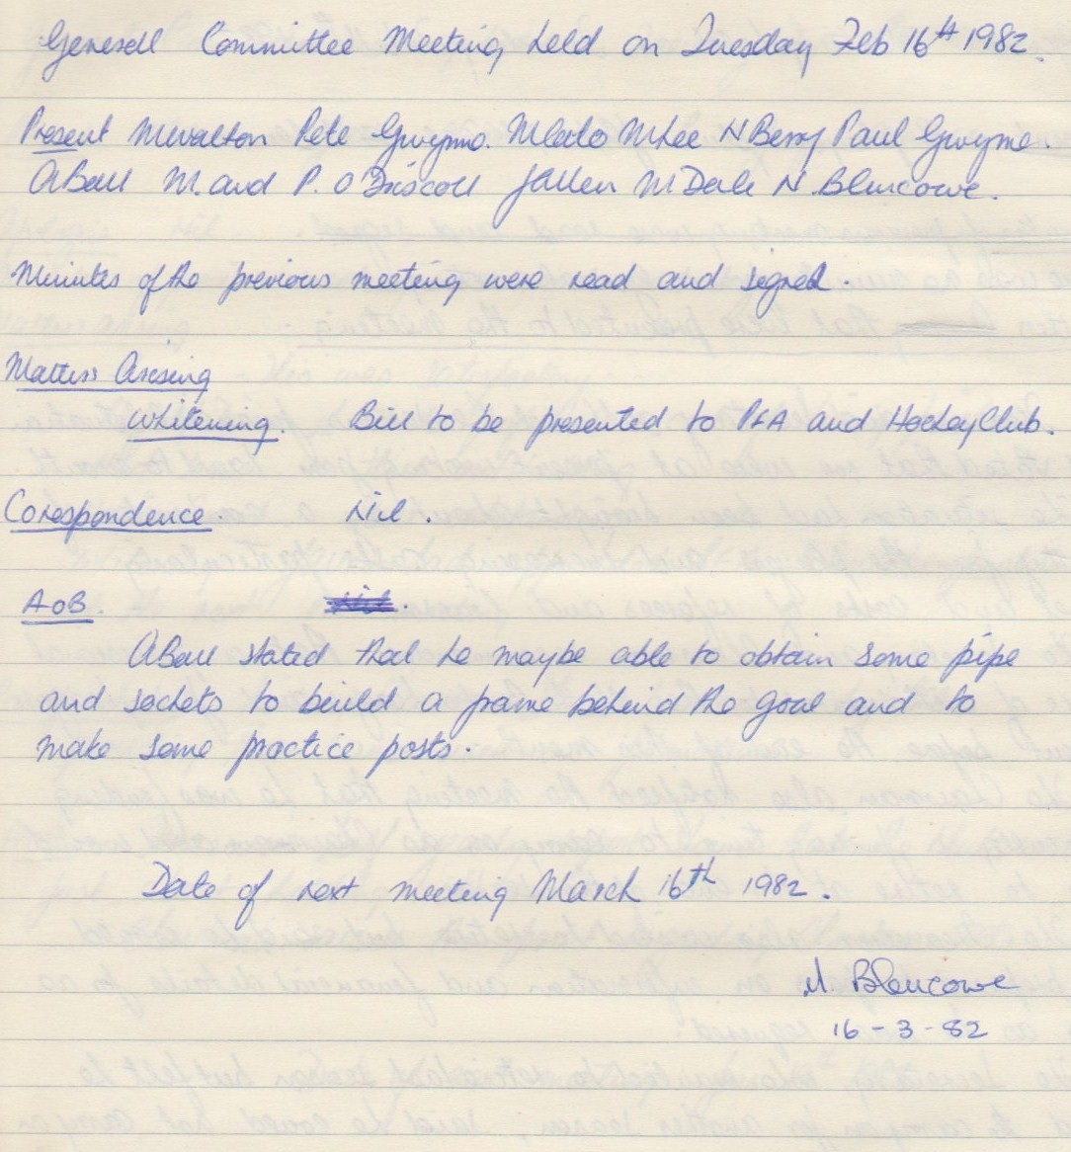

**General Committee Meeting**

**March 16th 1982**

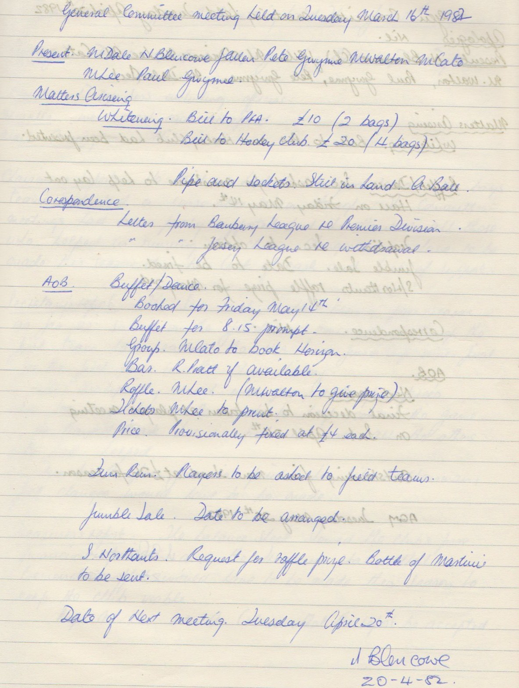

**General Committee Meeting**

**April 20th 1982**

